CHAPTER

TCP/IP Protocol Suite

5.1 Introduction
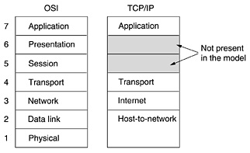
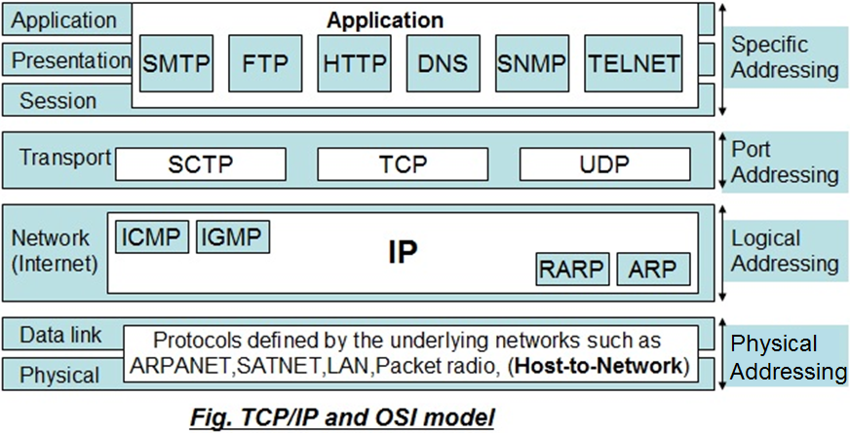
The Transmission Control Protocol / Internet Protocol (TCP/IP) is a set of protocol or a protocol suite that defines how all transmissions are exchanged across the internet. It was first defined in 1974 earlier to the OSI model. Therefore, the layers in the TCP/IP protocol suite do not exactly match those in the OSI reference model. TCP/IP is a hierarchical protocol made up of interactive modules, each of which provides a specific functionality; however, the modules are not necessarily interdependent. The TCP/IP protocol suite has 4 layers: i) Host-to-Network layer, ii) Internet layer, iii) Transport layer and iv) Application layer.

The Internet protocol suite, commonly known as TCP/IP, is a framework for organizing the set of communication protocols used in the Internet and similar computer networks according to functional criteria. The foundational protocols in the suite are the Transmission Control Protocol (TCP), the User Datagram Protocol (UDP), and the Internet Protocol (IP).

- Host-to-Network layer
This layer does not define any specific protocol. It supports all the standard and proprietary protocols. A network in a TCP/IP inter-network can be a local-area network or a wide-area network.

- Internet layer
- At this layer, TCP/IP supports the Internetworking Protocol. IP, in turn, uses four supporting protocols: Address Resolution Protocol (ARP) Reverse Address Resolution Protocol (RARP) Internet Control Message Protocol (ICMP)Internet Group Message Protocol (IGMP)

- The Internetworking Protocol (IP) is the transmission mechanism used by the TCP/IP protocols. It is an unreliable and connectionless protocol-a best-effort delivery service. The term best effort means that IP provides no error checking or tracking. This layer does its best to deliver message to its destination, but with no guarantees.
- IP transports data in packets called datagram, each of which is transported separately. Datagram can travel along different routes and can arrive out of sequence or be duplicated. IP does not keep track of the routes and has no facility for reordering datagram once they arrive at their destination.

- Transport layer
- It is a host-to-host protocol meaning that it can deliver a packet from one physical device to another. UDP and TCP are transport level protocols responsible for delivery of a message from a process (running program) to another process. A new transport layer protocol, SCTP, has been devised to meet the needs of some newer applications.
- TCP is a reliable, connection-oriented protocol that provides error checking and flow control through a virtual link that it establishes and finally terminates. TCP is responsible for the establishment of a TCP connection (TCP handshake), the sequencing and acknowledgment of packets sent, and the recovery of packets lost during transmission.
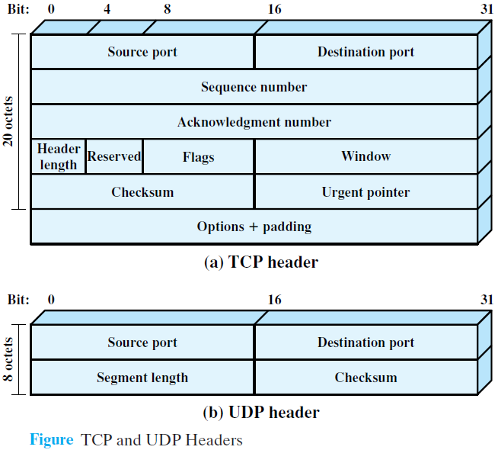
- UDP is an unreliable, connectionless protocol that provides data transport with lower network traffic overheads than TCP. UDP is used when the amount of data to be transferred is small (such as the data that would fit into a single packet), or when the overhead of establishing a TCP connection is not desired or when the applications or upper layer protocols provide reliable delivery. UDP does not error check or offer any flow control; this is left to the application process. Still it can be used by protocols that provide reliable packet transmission like NFS.
- Stream Control Transmission Protocol (SCTP): It provides support for newer applications such as voice over the Internet. It is a transport layer protocol that combines the best features of UDP and TCP.

- It is a connection oriented protocol & hence is reliable.
- The data is sending in the form of byte-stream (or Character oriented).
- The connection must be established before application level protocol exchange the information.
- Two way communication possible.
- Guaranteed delivery due to error correction (or flow control) mechanism.
- Used to send the important data such as Webpages, database information etc.
- Only concerns with accuracy so the speed is automatically slow.
- The data frame is 32-bit wide.

Transmission Control Protocol (TCP)

- It is connectionless protocol & hence considered as unreliable.
- The data is sending in the form of packet (or bit-oriented).
- Immediately exchange the information by application level protocol.
- Two way communication possible.
- No flow control mechanism so unsecured communication.
- It has high speed to deliver the data so used for real time audio, video exchange.
- Only concerned with speed but not accuracy.
- The data frame is 32-bit wide.
User Datagram Protocol (UDP)

- Application layer
The application layer in TCPIP is equivalent to the combined session, presentation, and application layers in the OSI model & many protocols are defined at this layer. The application layer is responsible for providing services to the user. It contains all higher level protocols to access the network resources such as: TELNET, FTP, SMTP, DNS, and POP etc.
- TELNET: It is a virtual terminal protocol and allows user on one machine to log onto the distant machine.
- FTP (File Transfer Protocol): It provides a way to move data efficiency from one machine to another.
- SMTP (Simple Mail Transfer Protocol): It is used to send E-mail, just as a kind of file transfer.
- DNS (Domain Name System): It is used for mapping host name onto their network addresses (IP addresses).

5.2 Connecting Devices
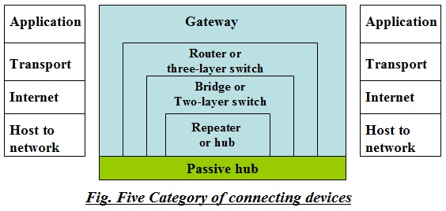
To connect LANs, or segments of LANs, we use connecting devices. We divide connecting devices into five different categories based on the layer in which they operate in a network.

5.2.1 Passive Hubs
A passive hub is just a connector. It connects the wires coming from different branches. In a star-topology Ethernet LAN, a passive hub is just a point where the signals coming from different stations collide; the hub is the collision point. This type of a hub is part of the media; its location in the Internet model is below the physical layer.

5.2.2 Repeater
A repeater receives a signal and, before it becomes too weak or corrupted, regenerates the original bit pattern. The repeater then sends the refreshed signal. A repeater can extend the physical length of a LAN. A repeater does not actually connect two LANs; it connects two segments of the same LAN. The segments connected are still part of one single LAN. A repeater is not a device that can connect two LANs of different protocols.
- A repeater forwards every frame; it has no filtering capability.
- A repeater is a regenerator, not an amplifier.

5.2.3 Active Hubs
An active hub is actually a multipart repeater. It is normally used to create connections between stations in a physical star topology.
- Hubs can also be used to create multiple levels of hierarchy.
- Hub required electrical power to run.

    - Bridges
A bridge operates in both the physical and the data link layer.
- Physical layer device: - Regenerates the signal it receives.
- Data link layer device: - Check the physical (MAC) addresses (source and destination) contained in the frame.
- A bridge does not change the physical (MAC) addresses in a frame.
- A bridge has a table used in filtering decisions.
- Bridge connect two LANs (two or more segment of LANs) having same connecting protocol but different hardware.

5.2.5 Two-Layer Switch
A two-layer switch is a bridge, a bridge with many ports and a design that allows better (faster) performance. A two-layer switch, as a bridge does, makes a filtering decision based on the MAC address of the frame it received.
- It can have a buffer to hold the frames for processing.
- It can have a switching factor that forwards the frames faster.
- No traffic or collision as the Ethernet.

5.2.6 Routers
A router is a three-layer device that routes packets based on their logical addresses (host-to-host addressing). A router normally connects LANs and WANs in the Internet and has a routing table that is used for making decisions about the route. The routing tables are normally dynamic and are updated using routing protocols.

5.2.6 Three-Layer Switches
A three-layer switch is a router, but a faster and more sophisticated. The switching fabric in a three-layer switch allows faster table lookup and forwarding.

5.2.7 Gateway
A gateway is normally a computer that operates in all five layers of the Internet or seven layers of OSI model. A gateway takes an application message, reads it, and interprets it. This means that it can be used as a connecting device between two inter-networks that use different models. Thus, the gateway can connect networks having different protocols and they may or may not have the similar hardware.
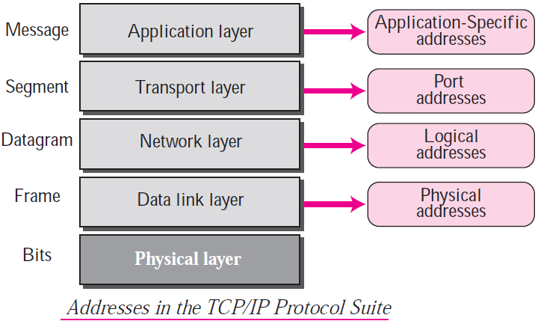

5.3 TCP/IP Addressing
Four levels of addresses are used in an internet employing the TCP/IP protocols: physical address, logical address, port address, and application-specific address. Each address is related to a one layer in the TCP/IP architecture, as shown in figure.

5.3.1 Physical Addresses
The physical address, also known as the link address, is the address of a node as defined by its LAN or WAN. It is included in the frame used by the data link layer. It is the lowest-level address. The physical addresses have authority over the link (LAN or WAN). The size and format of these addresses vary depending on the network. For example, Ethernet uses a 6-byte (48-bit) physical address that is imprinted on the network interface card (NIC). Local Talk (Apple), however, has a 1-byte dynamic address that changes each time the station comes up. Most local area networks use a 48-bit (6-byte) physical address written as 12 hexadecimal digits; every byte (2 hexadecimal digits) is separated by a colon, as shown below: 07:01:02:01:2C:4B

In figure a node with physical address 10 sends a frame to a node with physical address 87. The two nodes are connected by a link (a LAN). At the data link layer, this frame contains physical (link) addresses in the header. These are the only addresses needed. The rest of the header contains other information needed at this level. The trailer usually contains extra bits needed for error detection. As the figure shows, the computer with physical address 10 is the sender, and the computer with physical address 87 is the receiver. The data link layer at the sender receives data from an upper layer. It encapsulates the data in a frame, adding a header and a trailer. The header, among other pieces of information, carries the receiver and the sender physical (link) addresses. Note that in most data link protocols, the destination address 87 in this case, comes before the source address (10 in this case). The frame is propagated through the LAN. Each stations with a physical address other than 87 drops the frame because the destination address in the frame does not match its own physical address. The intended destination computer, however, finds a match between the destination address in the frame and its own physical address. The frame is checked, the header and trailer are dropped, and the data part is de-capsulated and delivered to the upper layer.
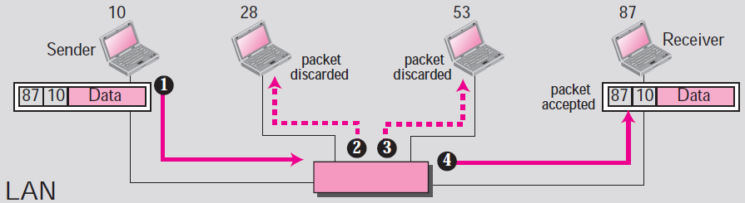

Physical addresses can be either unicast (one single recipient), multicast (a group of recipients), or broadcast (to be received by all systems in the network). Some networks support all three addresses. For example, Ethernet supports the unicast physical addresses (6 bytes), the multicast addresses, and the broadcast addresses. Some networks do not support the multicast or broadcast physical addresses. If a frame must be sent to a group of recipients or to all systems, the multicast or broadcast address must be simulated using unicast addresses. This means that multiple packets are sent out using unicast addresses.

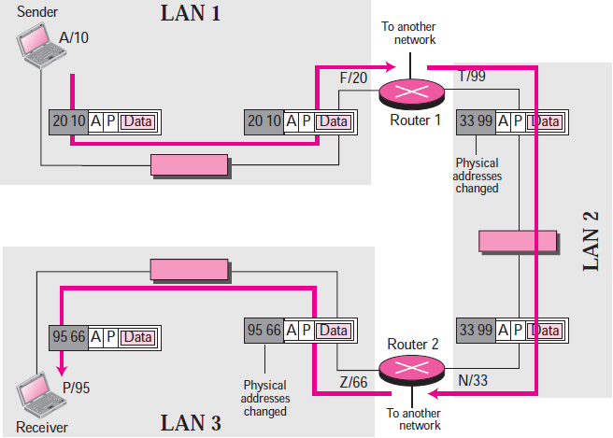
5.3.2 Logical Addresses
Logical addresses are necessary for universal communications that are independent of underlying physical networks. Physical addresses are not adequate in an internetwork environment where different networks can have different address formats. A universal addressing system is needed in which each host can be identified uniquely, regardless of the underlying physical network. The logical addresses are designed for this purpose. A logical address in the Internet is currently a 32-bit address that can uniquely define a host connected to the Internet. No two publicly addressed and visible hosts on the Internet can have the same IP address.

The physical addresses will change from hop to hop, but the logical addresses remain the same. For example: The computer with logical address A and physical address 10 needs to send a packet to the computer with logical address P and physical address 95. We use letters to show the logical addresses and numbers for physical addresses, but note that both are actually numbers. The source physical address changes from 10 to 99. The destination physical address will changes from 20 (router 1 physical address) to 33 (router 2 physical address). The logical source and destination addresses must remain the same; otherwise the packet will be lost.
A logical address in the internet is currently either of 32-bits (IPV4) or 128-bits (IPV6). The logical addresses can be either unicast (one single recipient), multicast (a group of recipients), or broadcast (all systems in the network). There are limitations on broadcast addresses.

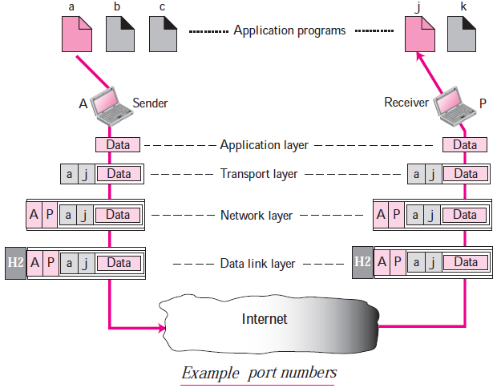
5.3.3 Port Addresses
The IP address and the physical address are necessary for a quantity of data to travel from a source to the destination host. However, arrival at the destination host is not the final objective of data communications on the Internet. A system that sends nothing but data from one computer to another is not complete. Today, computers are devices that can run multiple processes at the same time. The end objective of Internet communication is a process communicating with another process. For example, computer A can communicate with computer C by using TELNET. At the same time, computer A communicates with computer B by using the File Transfer Protocol (FTP). For these processes to receive data simultaneously, we need a method to label the different processes. In other words, they need addresses. In the TCP/IP architecture, the label assigned to a process is called a port address. A port address in TCP/IP is 16 bits in length, represented by one decimal number. Thus, the possible addresses are 2¹⁶ and out of which first 1024 addresses are dedicated and other for general use.
The physical addresses change from hop to hop, but the logical and port addresses usually remain the same. For example: two computers communicating via the Internet. The sending computer is running three processes at this time with port addresses a, b, and c. The receiving computer is running two processes at this time with port addresses j and k. Process a in the sending computer needs to communicate with process j in the receiving computer. Note that although both computers are using the same application, FTP, for example, the port addresses are different because one is a client program and the other is a server program. To show that data from process a need to be delivered to process j, and not k, the transport layer encapsulates data from the application layer in a packet and adds two port addresses (a and j), source and destination. The packet from the transport layer is then encapsulated in another packet at the network layer with logical source and destination addresses (A and P). Finally, this packet is encapsulated in a frame with the physical source and destination addresses of the next hop. We have not shown the physical addresses because they change from hop to hop inside the cloud designated as the Internet. Note that although physical addresses change from hop to hop, logical and port addresses remain the same from the source to destination.

5.3.4 Application-Specific Addresses
Some applications have user-friendly addresses that are designed for that specific application. Examples include the e-mail address (for example, NAST@gmail.com) and the Universal Resource Locator (URL) (for example, www.nast.edu.np). The first defines the recipient of an e-mail; the second is used to find a document on the World Wide Web. These addresses, however, get changed to the corresponding port and logical addresses by the sending computer.

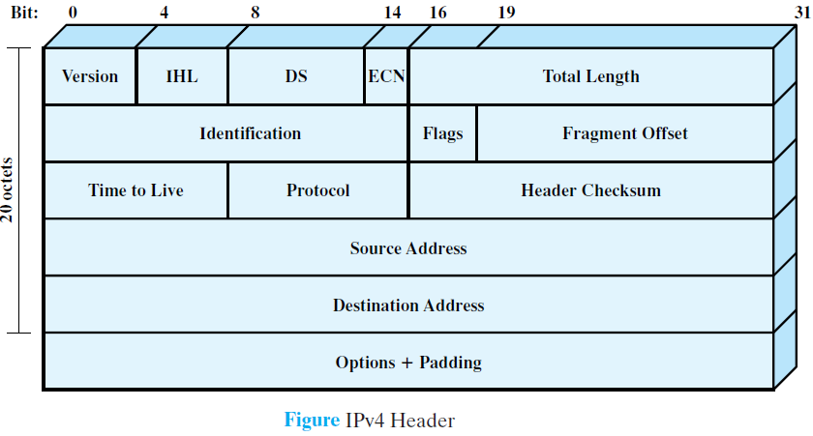
5.4 IPV4 Frame Format
The protocol between IP entities is best described with reference to the IP datagram format, shown in figure. The fields are as follows:
- Version (4 bits): Indicates version number, to allow evolution of the protocol, the value is 4.
- Internet Header Length (IHL) (4 bits): It indicates the length of header which is 32-bit words.
- DS/ECN (8 bits): Prior to the introduction of differentiated services, this field was referred to as the Type of Service (e.g. text, audio, video etc.) field and specified reliability, precedence, delay, and throughput parameters. This interpretation has now been superseded. The first six bits of this field are now referred to as the DS (Differentiated Services) field. The remaining 2 bits are reserved for an ECN (Explicit Congestion Notification) field.
- Total Length (16 bits): Total datagram length, including header plus data, in octets.
- Identification (16 bits): A sequence number that, together with the source address, destination address, and user protocol, is intended to identify a datagram uniquely. Thus, this number should be unique for the datagram’s source address, destination address, and user protocol for the time during which the datagram will remain in the internet.
- Flags (3 bits): The flag deals with fragmentation and reassembly of packets of data unit. Among three bits of flag, the first bit is unused, second bit indicates “Do not fragment”, and third bit indicates “More fragment”.
- Fragment Offset (13 bits): Indicates where in the original datagram this fragment belongs, measured in 64-bit units. This implies that fragments other than the last fragment must contain a data field that is a multiple of 64 bits in length.
- Time to Live (8 bits): Specifies how long, in seconds, a datagram is allowed to remain in the internet. Every router that processes a datagram must decrease the TTL by at least one, so the TTL is similar to a hop count.
- Protocol (8 bits): This field defines which upper layer protocol data are encapsulated in the datagram. This means that, it select the suitable protocol (e.g. connectionless or connection oriented) for next layer. Example values are TCP = 6; UDP =17, ICMP =1 and so on.
- Header Checksum (16 bits): The header checksum is an error-detecting code applied to the header only. The algorithm is to add up all the 16-bit half words of the header as they arrive, using one’s complement arithmetic, and then take the one’s complement of the result. For purposes of this algorithm, the Header checksum is assumed to be zero upon arrival.
- Source Address (32 bits) and Destination Address (32 bits): The Source address and Destination address indicate the IP address of the source and destination network interfaces.
- Options (variable): Encodes the options requested by the sending user.
- Padding (variable): Used to ensure that the datagram header is a multiple of 32 bits in length.
- Data (variable): The data field must be an integer multiple of 8 bits in length. The maximum length of the datagram (data field plus header) is 65,535 octets.

5.5 IP Addresses and Classes
An IP address is a numeric identifier assigned to each machine on an IP network. It designates the specific location of a device on the network. An IPv4 address is a 32-bit address that uniquely and universally defines the connection of a host or a router to the Internet; an IP address is the address of the interface. IPv4 addresses are unique. They are unique in the sense that each address defines one, and only one, connection to the Internet. Two devices on the Internet can never have the same address at the same time. However, if a device has two connections to the Internet, via two networks, it has two IPv4 addresses. The IPv4 addresses are universal in the sense that the addressing system must be accepted by any host that wants to be connected to the Internet.

IPv4 uses 32-bit addresses, which means that the address space is 2³² or 4,294,967,296 (more than four billion). Theoretically, if there were no restrictions, more than 4 billion devices could be connected to the Internet.

5.5.1 Notation
There are three common notations to show an IPv4 address: binary notation (base 2), dotted-decimal notation (base 256), and hexadecimal notation (base 16).
- Binary Notation: 01110101 10010101 00011101 11101010
- Dotted-Decimal Notation: 128.11.3.31
- Hexadecimal Notation: 10000001 00001011 00001011 11101111 = 0X810B0BEF or 810B0BEF₁₆
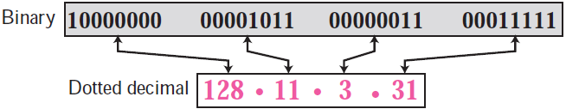

5.5.2 Classful Addressing
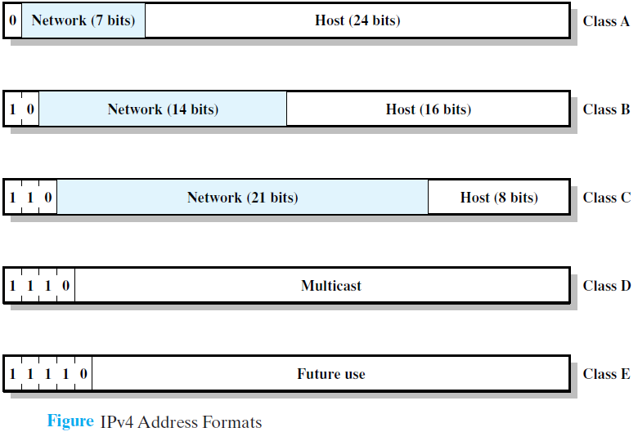
IP addresses, when started a few decades ago, used the concept of classes. This architecture is called classful addressing. In the mid-1990s, a new architecture, called classless addressing, was introduced that supersedes the original architecture. In classful addressing, the IP address space is divided into five classes: A, B, C, D, and E. The classes A, B, & C are used for unicast, class D is used for multicast and class E is reserved. Each class occupies some part of the whole address space.
- Class A: Few networks, each with many hosts
- Class B: Medium number of networks, each with a medium number of hosts
- Class C: Many networks, each with a few hosts

In classful addressing, an IP address in class A, B, or C is divided into netid and hostid. These parts are of varying lengths, depending on the class of the address as shown in figure above. Note that the concept does not apply to classes D and E. In c1assfnl addressing, a large part of the available addresses were wasted.

We can find the class of an address when the address is given either in binary or dotted decimal notation. In the binary notation, the first few bits can immediately tell us the class of the address; in the dotted-decimal notation, the value of the first byte can give the class of an address, as shown in figure.
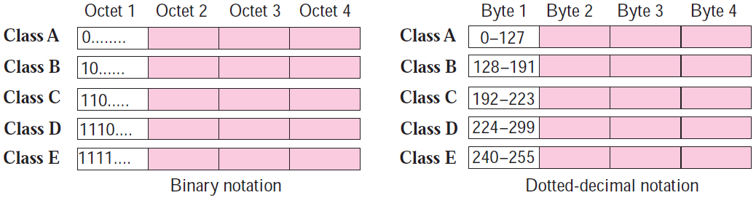

Computers often store IPv4 addresses in binary notation. In this case, it is very convenient to write an algorithm to use a continuous checking process for finding the address as shown in figure.
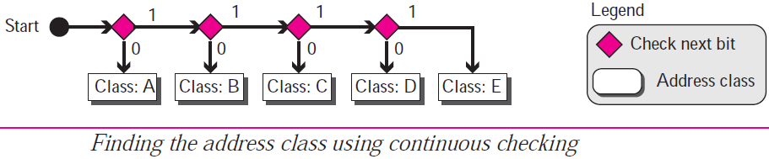

Example:
Find the class of each address.
- 00000001 00001011 00001011 11101111 = First bit is 0. This is a class A address.
- 11000001 10000011 00011011 11111111= First 2 bits are 1; the third bit is 0. This is a class C address.
- 14.23.120.8 = First byte is 14 (between 0 and 127); the class is A.
- 252.5.15.111= First byte is 252 (between 240 and 255); the class is E.
5.5.2.1 Address Masking
Although the length of the netid and hostid (in bits) is predetermined in classful addressing, we can also use a mask (also called the default mask), a 32-bit number made of contiguous 1s followed by contiguous 0s. The default masks for classes A, B, and C are shown in following table. The concept does not apply to classes D and E.
Class | Binary | Dotted-Decimal | CIDR
A | 11111111 00000000 00000000 00000000 | 255.0.0.0 | /8
B | 11111111 11111111 00000000 00000000 | 255.255.0.0 | /16
C | 11111111 11111111 11111111 00000000 | 255.255.255.0 | /24

In IPv4 addressing, a block of addresses can be defined as x.y.z.t /n in which x.y.z.t defines one of the addresses and the /n defines the mask. The last column of table shows the mask in the form /n where n can be 8, 16, or 24 in classful addressing. This notation is also called slash notation or Classless Inter-domain Routing (CIDR) notation. The notation is used in classless addressing, and also be applied to classful addressing.

5.5.3 Classless Addressing
To overcome address depletion and give more organizations access to the Internet, classless addressing was designed and implemented. In this scheme, there are no classes, but the addresses are still granted in blocks.

5.5.3.1 Classless Mask
In case of the binary representation of IP address space (for both classful and classless). The first address can be found by ANDing the given addresses with the mask. ANDing here is done bit by bit. The result of ANDing 2 bits is 1 if both bits are 1s; the result is 0 otherwise. The last address can be found by ORing the given addresses with the complement of the mask. ORing here is done bit by bit. The result of ORing 2 bits is 0 if both bits are 0s; the result is 1 otherwise. The complement of a number is found by changing each 1 to 0 and each 0 to 1.
For example: First address of 205.16.37.39/28
Address: 11001101 00010000 00100101 00100111
Mask: 11111111 11111111 11111111 11110000
First address: 11001101 00010000 00100101 00100000

For example: Last address of 205.16.37.39/28
Address: 11001101 00010000 00100101 00100111
Mask complement: 00000000 00000000 00000000 00001111
Last address: 11001101 00010000 00100101 00101111

5.5.3.2 Subnetting
As the name illustrates, the subnetting is the technique of dividing a large network into many smaller networks. The subnetting increase the default Classless Inter-domain Routing (CIDR) value assigned to class A, B, and C. In other word, the subnetting increases the number of ones in the mask. For example: the classful address 192.168.0.0/24 can be converted into the classless address 192.168.0.0/25 after subnetting. Thus, the subnetting increases the number of networks and decreases the number of hosts in each network. The main advantages of the subnetting are reduced network traffic, optimized network performance, simplified management, and facilitated spanning of large geographical distances.

For example: For the network address: 192.168.10.0/25
Here,
- Network address (class-C): 192.168.10.0
- Subnet mask (Dotted decimal): 255.255.255.128
- Subnet mask (Binary): 11111111 11111111 11111111 10000000
Now,
- Number of subnet (networks) = 2¹ = 2
- Valid subnets = 256-128 = 128 (Thus, next subnet start from 128 i.e. two networks are: 192.168.10.0 and 192.168.10.128)
- Number of hosts per subnet = 2⁷ = 128 (Here, 7 represent the number of zeros on last block of binary subnet mask)
- Number of valid IP = 2⁷ – 2 = 128 – 2 = 126 (Since, the first IP address is reserved as network address and last is for broadcast)

For example: For the network address: 192.168.0.0/30
Here,
- Network address (class-C): 192.168.0.0
- Subnet mask (Dotted decimal): 255.255.255.252
- Subnet mask (Binary): 11111111 11111111 11111111 11111100
Now,
- Number of subnet (networks) = 2⁶ = 64
- Valid subnet = 256-252 = 4 (now take the multiple of 4 in increasing way and thus we can find 64 addresses)
- Number of hosts per subnet = 2² = 4 (Here, 2 represent the number of zeros on last block of binary subnet mask)
- Number of valid IP = 2² – 2 = 4 – 2 = 2 (Since, the first IP address is reserved as network address and last is for broadcast)
Thus,
Network | IP assignment
First Network | - Network address: 192.168.0.0/30  - Valid IP for host -1: 192.168.0.1/30  - Valid IP for host -2: 192.168.0.2/30  - Broadcast address: 192.168.0.3/30
Second network | - Network address: 192.168.0.4/30  - Valid IP for host -1: 192.168.0.5/30  - Valid IP for host -2: 192.168.0.6/30  - Broadcast address: 192.168.0.7/30

5.5.3.3 Supernetting
As the name illustrates, the supernetting is the technique of integrating many smaller networks into a large network. The subnetting decreases the default Classless Inter-domain Routing (CIDR) value assigned to class A, B, and C. In other word, the subnetting decreases the number of ones in the mask. For example: the classful address 192.168.0.0/24 can be converted into the classless address 192.168.0.0/23 after supernetting. Thus, the supernetting decreases the number of networks and increases the number of hosts in each network. The supernetting is generally used to reduce the state information on routing table as the router has limited memory. The operation of supernetting is same as subnetting as mentioned above.

5.6 Introduction to IPV6
IPv6 (Internetworking Protocol, version 6), also known as IP_{ng} (Internetworking Protocol, next generation), was proposed and is now a standard. The main drawbacks of the IPV4 are the insufficient address space, no real time audio-video accommodation, and no provision of encryption & authentication. Thus, the concept of IPV4 was arises with its following major goals:
- Support billions of hosts, even with inefficient address allocation.
- Reduce the size of the routing tables.
- Simplify the protocol, to allow routers to process packets faster.
- Provide better security (authentication and privacy).
- Pay more attention to the type of service, particularly for real-time data.
- Aid multicasting by allowing scopes to be specified.
- Make it possible for a host to roam without changing its address.
- Allow the protocol to evolve in the future.
- Permit the old and new protocols to coexist for years.

An IPv6 address is 128 bits or 16 bytes (octet) long. The address length in IPv6 is four times of the length address in IPv4. The next-generation IP, or IPv6, has some advantages over IPv4 that can be summarized as follows: (A-HERO-Security)
- Larger address space: An IPv6 address is 128 bits long. Compared with the 32-bit address of IPv4, this is a huge (2⁹⁶) increase in the address space.
- Better header format: IPv6 uses a new header format in which options are separated from the base header and inserted, when needed, between the base header and the upper-layer data. This simplifies and speeds up the routing process because most of the options do not need to be checked by routers.
- Allowance for extension: IPv6 is designed to allow the extension of the protocol if required by new technologies or applications.
- Support for resource allocation: In IPv6, the type-of-service field has been removed, but a mechanism (called flow label) has been added to enable the source to request special handling of the packet. This mechanism can be used to support traffic such as real-time audio and video.
- New options: IPv6 has new options to allow for additional functionalities.
- Support for more security: The encryption and authentication options in IPv6 provide confidentiality and integrity of the packet.

IPV6 has three type of addresses, which are uni-cast (one interface), any-cast (nearest member communication), and multicast (delivery from one people to all group members). To map from the IPV4 into IPV6, the strategies are dual-stack (identify the version of IP), tunneling (data transmission between IPV4 to IPV6), and header transition (if sender use IPV6 but receiver does not understand it.)

5.6.1 Notations
The IP is a vehicle of internet which is used to send the data in far geographical region. A computer normally stores the address in binary, but is clear that 128 bits cannot easily be handled by humans. Several notations have been proposed to represent IPv6 addresses when they are handled by humans:
- Dotted-Decimal Notation: 221.14.65.11.105.45.170.34.12.234.18.0.14.0.115.255 (Rarely used)
- Colon Hexadecimal Notation: FDEC:BA98:7654:3210:ADBF:BBFF:2922:FFFF

Mixed Representation
Sometimes we see a mixed representation of an IPv6 address: colon hex and dotted decimal notation. This is appropriate during the transition period in which an IPv4 address is embedded in an IPv6 address (as the rightmost 32 bits). We can use the colon hex notation for the leftmost six sections and four bytes dotted-decimal notation instead of the rightmost two sections as shown below: FDEC:14AB:2311:BBFE:AAAA:BBBB:130.24.24.18

Zero compression
Further abbreviation, often called zero compression, can be applied to colon hex notation if there are consecutive sections consisting of zeros only. We can remove all the zeros altogether and replace them with a double semicolon, as shown in figure.
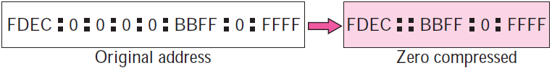

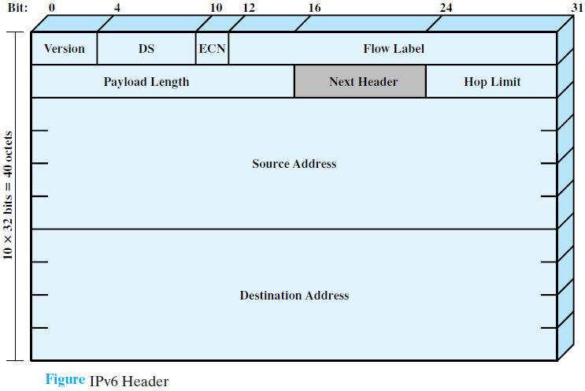
5.6.2 IPv6 Header
The IPv6 header has a fixed length of 40 octets, consisting of the following fields
- Version (4 bits): Internet protocol version number; the value is 6.
- DS/ECN (8 bits): Available for use by originating nodes and/or forwarding routers for differentiated services and congestion functions, as described for the IPv4 DS/ECN field.
- Flow Label (20 bits): May be used by a host to label those packets for which it is requesting special handling by routers within a network; discussed subsequently.
- Payload Length (16 bits): Length of the remainder of the IPv6 packet following the header, in octets. In other words, this is the total length of all of the extension headers plus the transport-level PDU.
- Next Header (8 bits): Identifies the type of header immediately following the IPv6 header; this will either be an IPv6 extension header or a higher-layer header, such as TCP or UDP.
- Hop Limit (8 bits): The remaining number of allowable hops for this packet. The hop limit is set to some desired maximum value by the source and decremented by 1 by each node that forwards the packet. The packet is discarded if Hop Limit is decremented to zero. This is a simplification over the processing required for the Time to Live field of IPv4.The consensus was that the extra effort in accounting for time intervals in IPv4 added no significant value to the protocol. In fact, IPv4 routers, as a general rule, treat the Time to Live field as a hop limit field.
- Source Address (128 bits): The address of the originator of the packet.
- Destination Address (128 bits): The address of the intended recipient of the packet.

NOTE:
- Private IP: The private IP is used for local area connection (for internal use on an organization). The Private IP range is:
    - 10. 0. 0. 0 – 10. 255. 255. 255
    - 172. 26. 0. 0 – 172. 31. 255. 255
    - 192.168. 0. 0 – 192. 168. 255. 255, out of this range of IP, the IP is public IP range.
- Public IP: The public IP is used by connecting internet services from ISP (Internet Service Provider). Only after the connection to public IP, the data of local network will connected to the Internet.
- Loop back IP: 127. 0. 0. 1 = Local-host IP = Default IP, used for the network test.

